Title: Cloud-Based File Storage System using Google Cloud Platform (Mini Google Drive)
Author: S. Nakshatra

Contents
1. Abstract
2. Introduction
3. Problem Statement
4. Objectives
5. Literature Review
6. Existing System vs Proposed System
7. System Requirements
8. System Architecture
9. Detailed Module Explanation
10. Backend Implementation
11. Frontend Implementation
12. Cloud Deployment
13. Security Features
14. Testing & Validation
15. Results & Outputs
16. Conclusion
17. Future Enhancements
18. References

Abstract
Cloud computing has transformed the way digital information is stored, accessed, and shared. This project presents a cloud-based file storage system similar to Google Drive, offering functionalities such as user authentication, file upload, file viewing, secure storage, metadata management, and downloadable share links. The backend is powered by Flask and deployed using Google Cloud Run, while Google Cloud Storage handles file persistence and Firestore manages metadata. The system is lightweight, scalable, secure, and accessible from any device with an internet connection.
This report details the system design, architecture, implementation, cloud deployment, security mechanisms, testing, results, and future enhancements.

Introduction
The rapid growth of cloud computing has enabled flexible, scalable, and cost-effective solutions for storing and accessing data. Traditional storage systems such as hard drives, pen drives, and local servers pose limitations such as restricted access, risk of physical damage, lack of scalability, and absence of online collaboration.
To address these limitations, cloud platforms like Google Cloud Platform (GCP) provide services that support on-demand storage, serverless computing, scalable databases, and secure data operations. This project explores the design and development of a cloud-based file storage system (Mini Google Drive), leveraging GCP technologies.
The system provides:
- Secure user authentication
- File uploads
- File management
- Downloadable sharing links
- Cloud-based hosting and database
- A simple frontend interface
This project demonstrates how cloud services can be integrated to build real-world scalable applications.

Problem Statement
Traditional file storage methods suffer from:
- Limited accessibility
- Lack of centralized file management
- No backup protection
- Device dependency
- Difficulty in sharing files securely
- High infrastructure cost
Users increasingly require a platform that can store files securely in the cloud, access them from anywhere, and ensure reliability without managing physical hardware.

Objectives
The main objectives of this project are:
- To design and develop a cloud-based file storage system similar to Google Drive.
- To implement secure user authentication using JWT.
- To upload and store files in Google Cloud Storage.
- To maintain file metadata such as file name, user ID, URL, and timestamp in Firestore.
- To generate publicly shareable URLs for downloading files.
- To deploy the backend on Google Cloud Run for global accessibility.
- To provide a simple and user-friendly frontend for uploading and managing files.

Literature Review
Cloud storage systems have evolved significantly over the past decade. Several studies highlight the benefits of cloud-based systems:
- Scalability: Cloud infrastructure expands automatically as storage needs grow.
- Reliability: Data hosted on cloud providers enjoys redundancy and high durability (e.g., Google Cloud Storage offers 99.999999999% durability).
- Security: Cloud vendors implement advanced encryption, identity management, and access control.
- Cost-effectiveness: Serverless and pay-as-you-go models eliminate upfront investment.
Existing services like Google Drive, Dropbox, and OneDrive feature user authentication, cloud storage, file versioning, collaboration, and secure sharing.
This project implements a simplified version of these functionalities using GCP components.

Existing System vs Proposed System
Existing System (Traditional Storage)
- Files stored locally
- High chance of data loss
- No remote access
- No easy sharing
- Manual backup
- Expensive infrastructure for large-scale storage
Proposed Cloud-Based System
- Stores files in Cloud Storage
- Accessible from anywhere
- Automatic redundancy
- Secure sharing links
- Managed infrastructure
- Scalable as needed
- Built using serverless architecture for lower costs

System Requirements
7.1 Functional Requirements
- User must be able to create an account.
- User should be able to log in securely.
- User should be able to upload files.
- Uploaded files should be stored in Google Cloud Storage.
- File metadata must be saved in Firestore.
- User should be able to view uploaded files.
- User can generate a shareable download link.
- User must be able to delete files.

7.2 Non-Functional Requirements
- Scalability: Application should scale automatically under high load.
- Security: JWT-based authentication, secure APIs, and restricted access.
- Performance: Fast file uploads & downloads via Google Cloud CDN-backed storage.
- Availability: Cloud Run ensures high availability.
- Usability: Simple and intuitive interface.
- Portability: Should work on all devices with a browser.

System Architecture
Components Used:
- Frontend: HTML, CSS, JavaScript
- Backend: Flask (Python)
- Authentication: JWT Tokens
- Storage: Google Cloud Storage
- Database: Firestore
- Deployment: Cloud Run
- Containerization: Docker (used internally during deployment)
Architecture Flow:
- User interacts with the frontend UI.
- Frontend sends requests to Flask backend on Cloud Run.
- Authentication is verified using JWT.
- Files are uploaded to Cloud Storage.
- Metadata is stored in Firestore.
- Backend returns endpoints for accessing files.

Detailed Module Explanation
1. User Authentication Module
- Signup requires email + password
- Passwords hashed using werkzeug
- JWT token generated on login
- User ID stored inside token
- Token validated in each restricted API request
2. File Upload Module
- Users upload any file type
- Upload API receives the file
- Filename renamed using UUID for uniqueness
- Stored in Cloud Storage
- Public URL stored in Firestore
3. File Listing Module
- Retrieves all files belonging to the user
- Each file includes:
  - File name
  - File URL
  - User ID
  - Timestamp

4. Share Link Module
- Signed URL generated using Cloud Storage
- URL is valid only for a limited time (1 hour)
- Safe for controlled sharing
5. File Deletion Module
- Deletes both file and its metadata
- Ensures database consistency

Backend Implementation
Technologies
- Python
- Flask
- Flask-CORS
- Google Cloud Storage API
- Firestore Client
- JWT
Method | Endpoint | Description
POST | /signup | Register user
POST | /login | Login & get JWT
POST | /upload | Upload file
GET | /files | List files
GET | /share/<name> | Signed download URL
DELETE /delete/<name> Remove file
Frontend Implementation
Pages
- index.html (Login page)
- signup.html (Registration page)
- dashboard.html (File upload & listing)
Features
- Simple and clean UI
- AJAX-based API calls
- Displays uploaded files dynamically
- Download/share/delete options

Cloud Deployment (GCP)
Steps:
- Create GCP project
- Enable APIs:
  - Cloud Run
  - Cloud Build
  - Cloud Storage
  - Firestore
- Create a bucket
- Initialize Firestore in Native Mode
- Build and deploy backend using: gcloud run deploy ...
- Allow unauthenticated access
- Test the live API
Security Features
- JWT authentication for each user
- Hashed passwords
- Signed URLs for file sharing
- Private bucket (optional)
- HTTPS through Cloud Run
- Least privilege IAM roles

Testing & Validation
Test Cases:
Test Case | Expected Result
Signup with new email | Success
Signup with existing email | Error message
Login with valid credentials | Returns token
Upload file | Stored successfully
List files | Displays all files
Generate share link | Valid URL
Delete file | Removes both file and metadata

Results & Output
The system successfully supports:
- User creation & login
- Cloud-based file storage
- Viewing uploaded files
- Secure file sharing
- Deleting files
- 24/7 global access via Cloud Run

Conclusion
This project demonstrates how cloud technologies can be used to build scalable, secure, and highly available file storage systems. By integrating Flask, Google Cloud Run, Cloud Storage, and Firestore, we achieved a complete cloud-native solution that mimics basic functionality of Google Drive.
The project highlights the strengths of serverless computing and demonstrates practical experience with cloud platforms.

Future Enhancements
- Folder-based organization
- File versioning
- User role management
- File preview (images, PDFs)
- Trash bin & recovery
- Multi-user shared workspace
- Mobile app version
References
- Google Cloud Documentation
- Flask Documentation
- JWT Authentication Standards
- Firestore Database Concepts
- Cloud Storage Best Practices

Screenshots
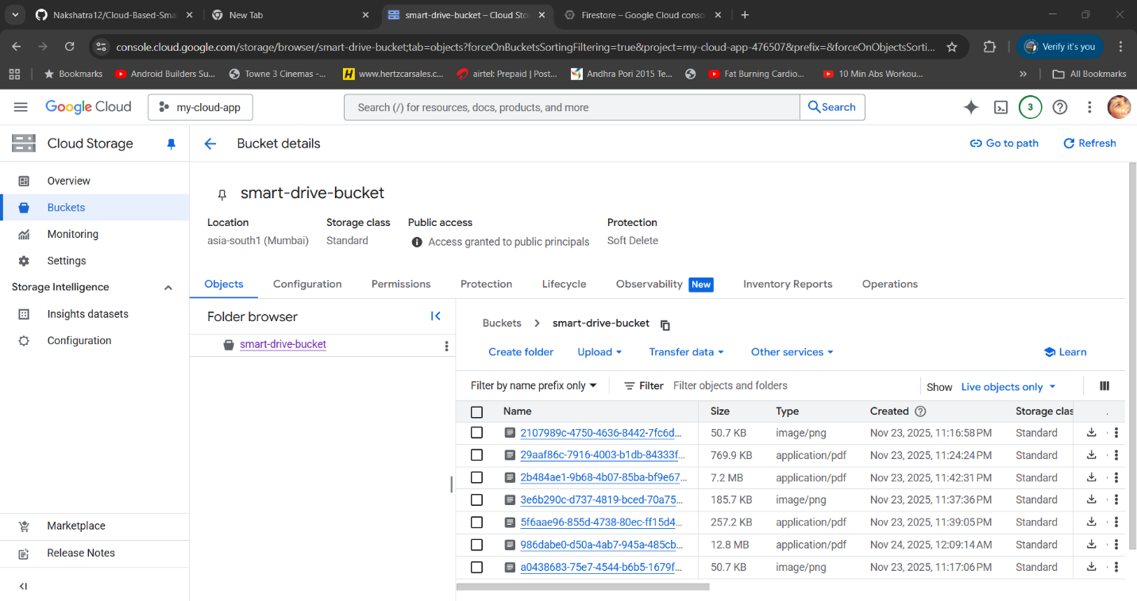
Storage Bucket
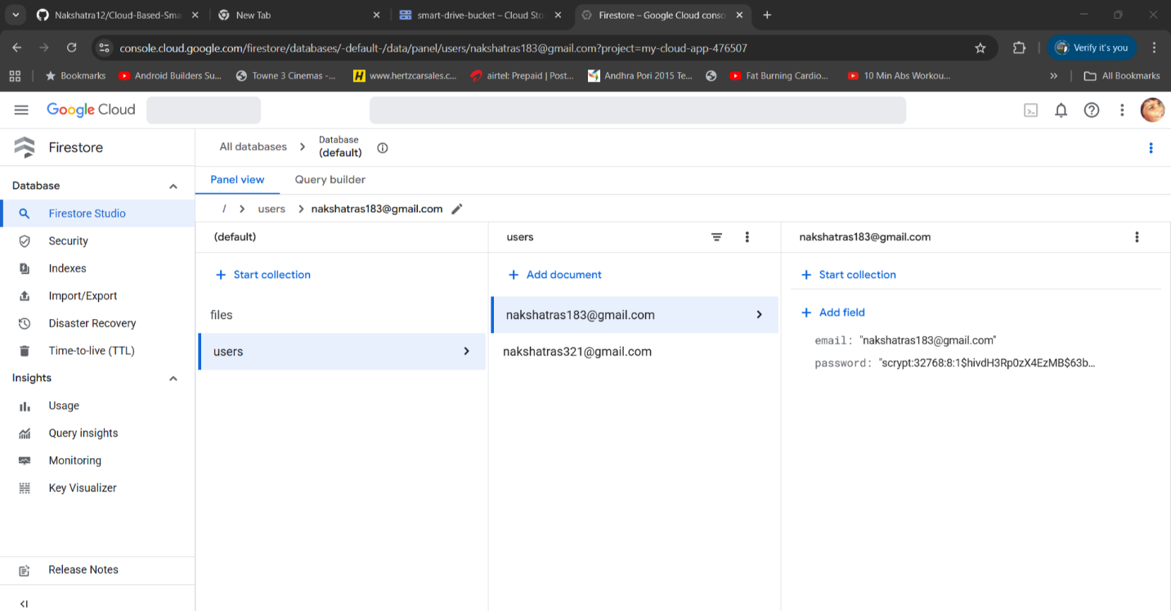
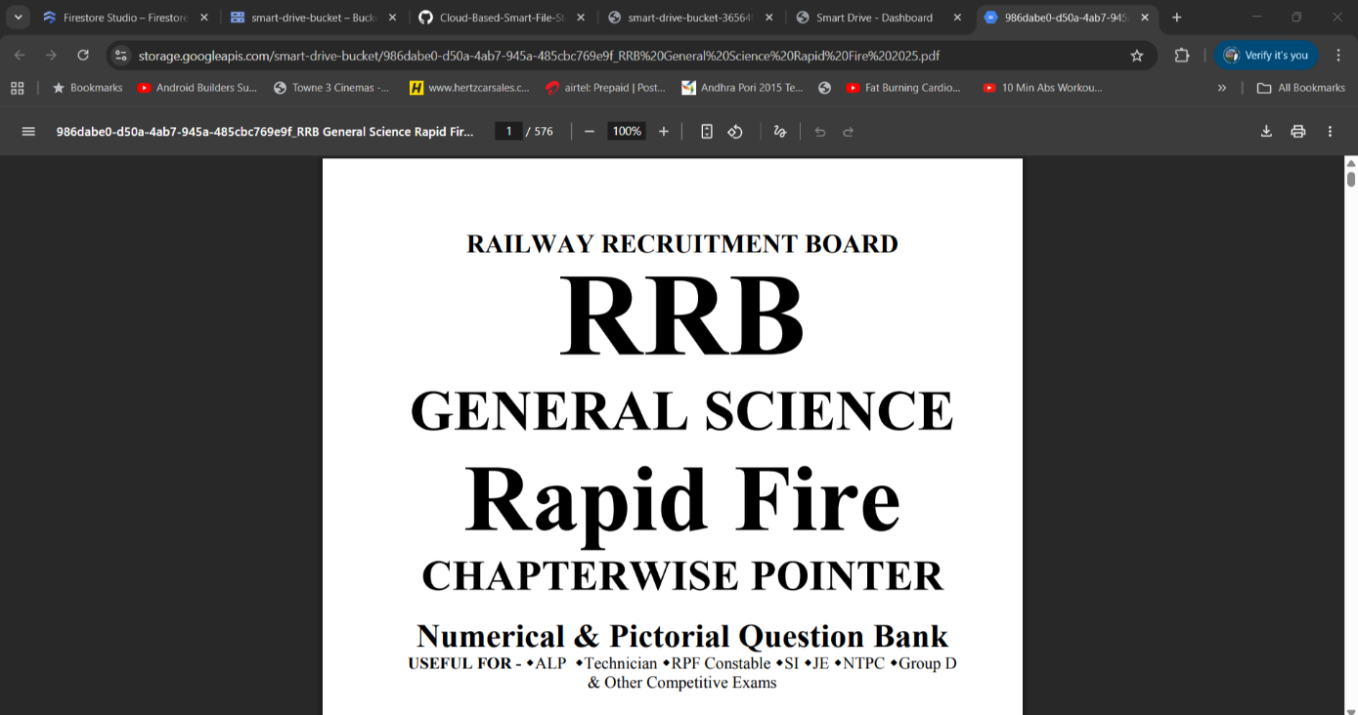
MetaData in Firestore

Download & Sharable Link

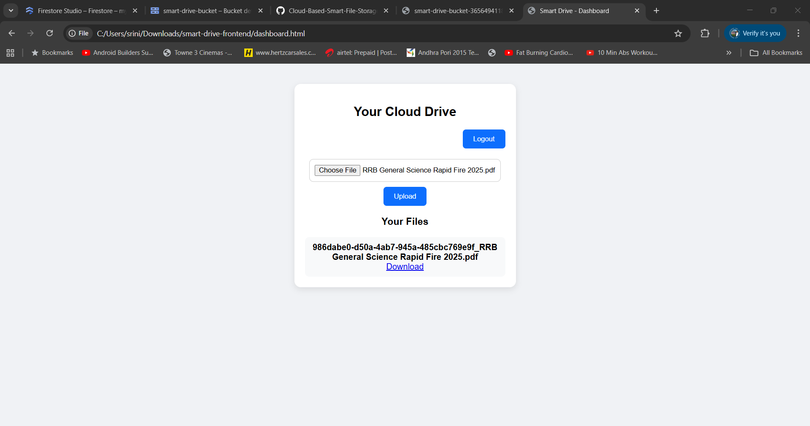
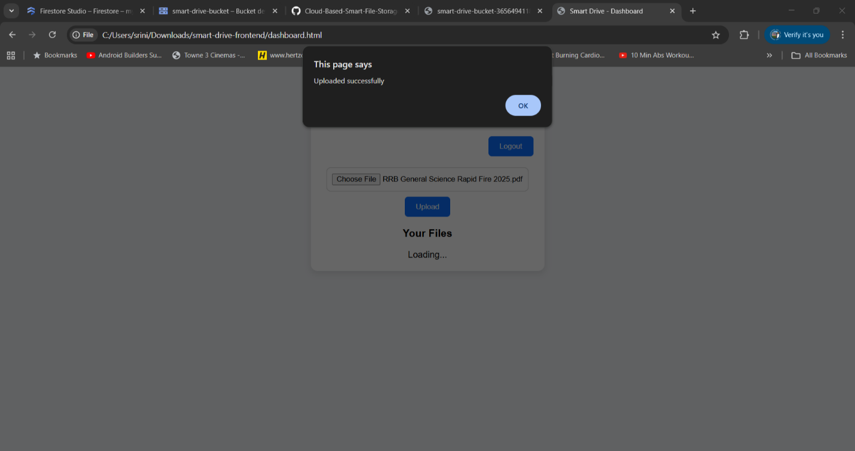
Uploaded Files
Uploaded Successfully

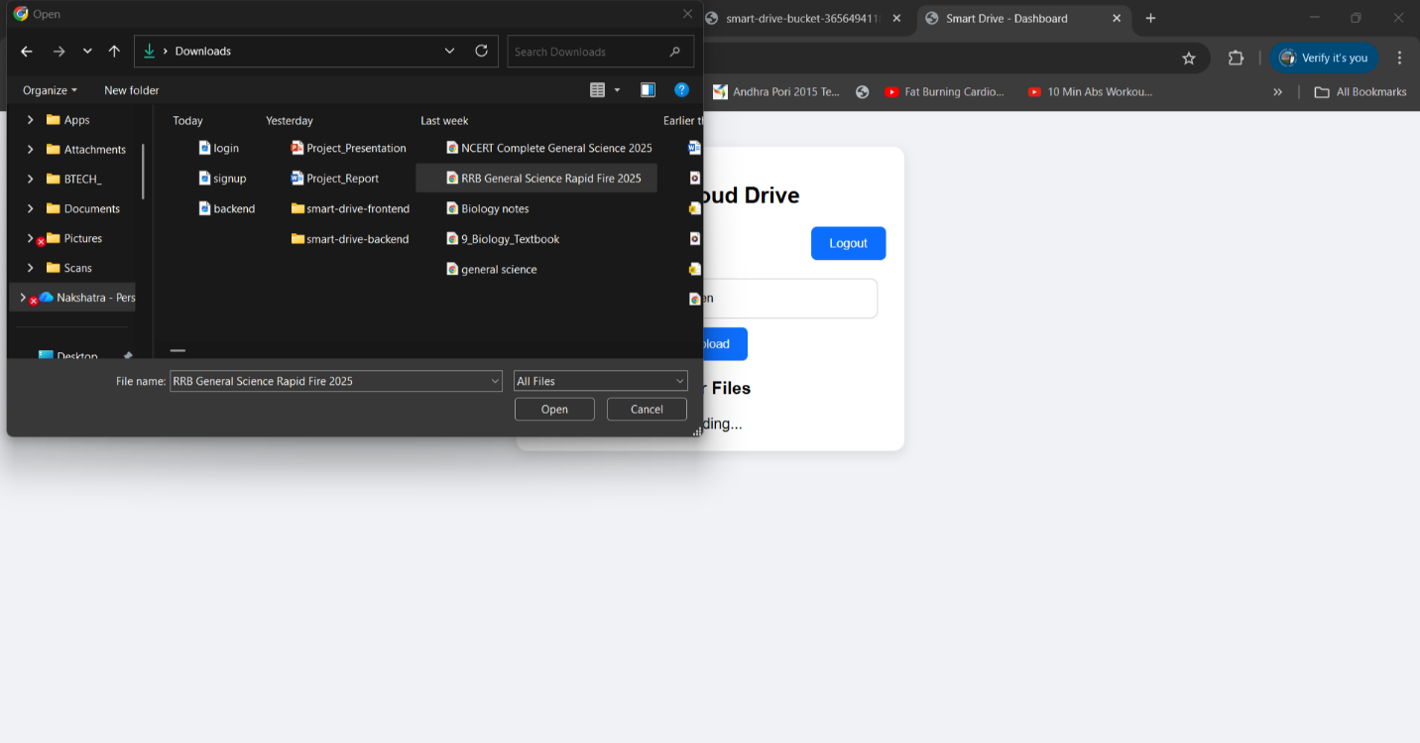
Uploading Files

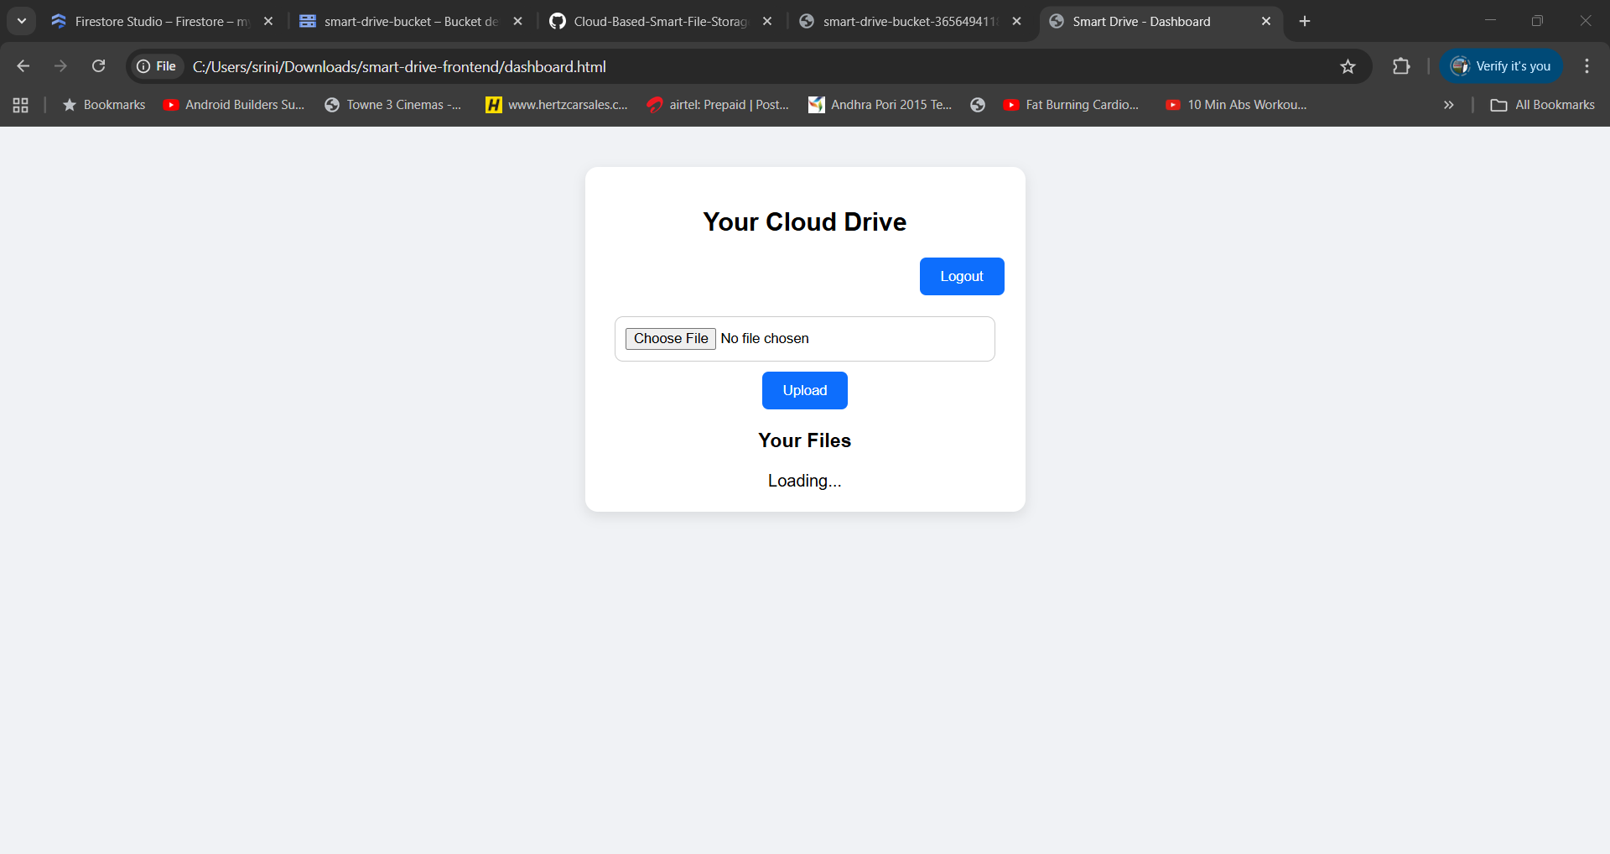
Files
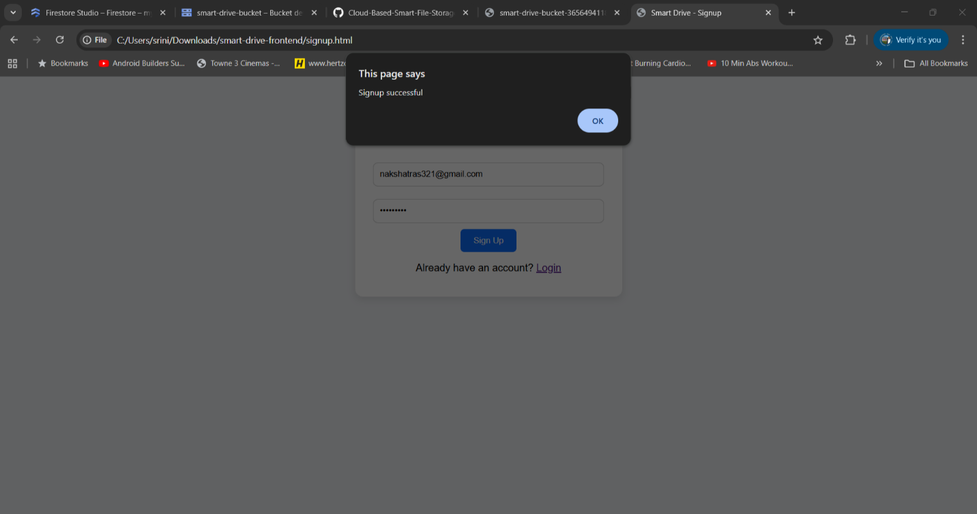
Signup Successful
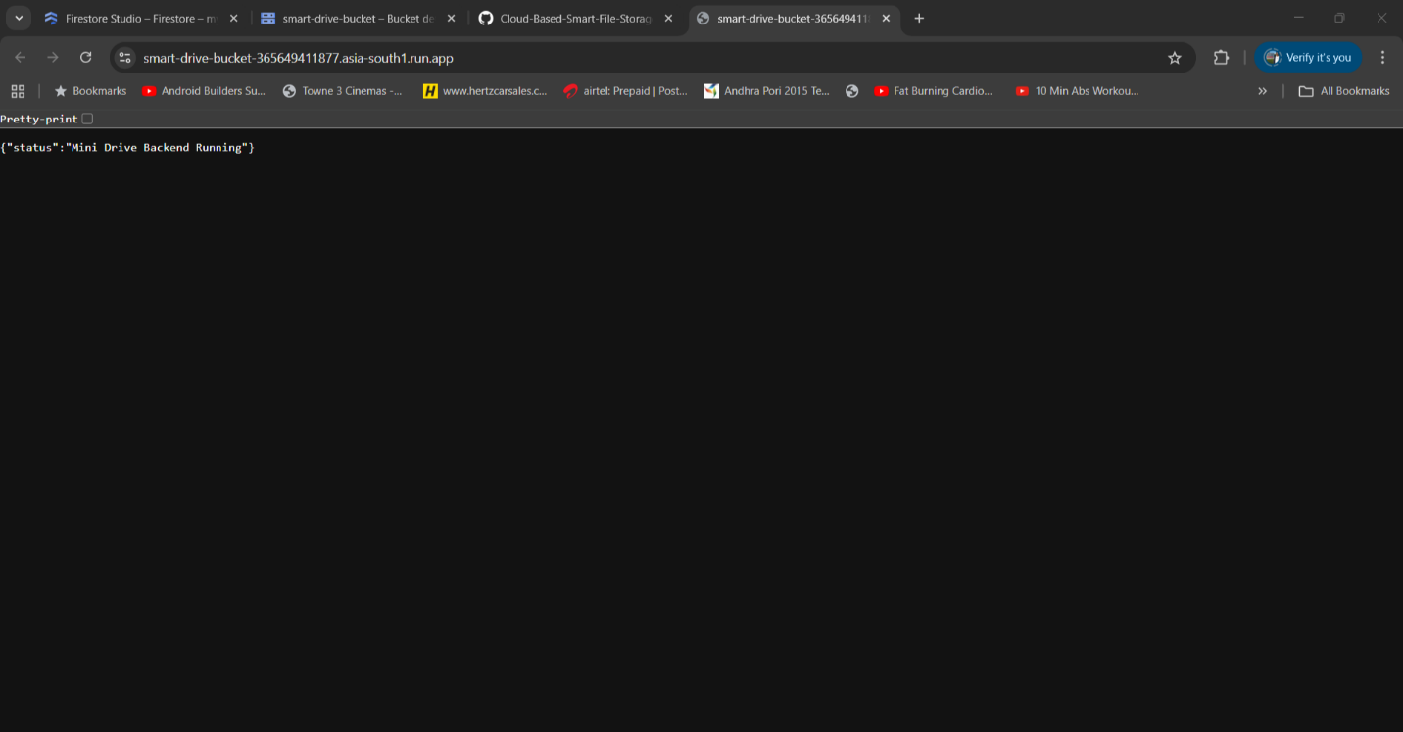
Backend

